

Agile Development Process and Devops
(ISWE406L)
School of Computer Science Engineering
and Information Systems
VIT, Vellore

By
Sabarissh S
23MIS0356

Under the guidance
of
Dr. Bala Ganesh N
1.Problem Statement:

2. System Architecture & Tech Stack

2.1 Architectural Overview
The System is designed using a Continuous Integration and Continuous Deployment (CI/CD) pipeline to ensure automation, reliability, and scalability. The system follows a structured workflow where development, testing, and deployment processes are executed automatically without manual intervention.
At its core, the system uses Java-based logic to analyze input text and calculate similarity scores using a word-based comparison approach. This logic is integrated into a DevOps pipeline to ensure that only validated code is deployed.
The process begins when a developer pushes code to GitHub, which triggers the Jenkins pipeline. Jenkins retrieves the code, builds the application using Maven, and executes JUnit test cases to validate duplicate detection and similarity thresholds. If any test fails, the pipeline stops immediately, ensuring code quality.
If the tests pass, the application is packaged into a JAR file and containerized using Docker. The Docker image is then pushed to DockerHub and deployed to a Kubernetes cluster. Kubernetes manages multiple instances of the application, ensuring high availability and scalability, while services provide external access.
This architecture minimizes manual effort, reduces errors, and enables fast and reliable deployment.

Architecture Flow
Developer → GitHub → Jenkins → Maven Build → JUnit Testing → Docker Build → DockerHub → Kubernetes Deployment → Running Application

3. Project Modules
Your project contains:
- Plagiarism Detection Module
- Similarity Calculation Module
- JUnit Testing Module
- CI/CD Pipeline Module
- Docker Containerization
- Kubernetes Deployment

Suggested Project Structure
Hello-World
├──hello-world-crud/
├── src/
│ ├── main/java/
│ │ ├── Main.java
│ │ ├── Message.java
│ │ └── MessageManager.java
│ │
│ └── test/java/
│ └── MessageManagerTest.java
│
├── Dockerfile
├── deployment.yaml
└── pom.xml
└──README.md

4. Implementation
4.1 Java Code :
Main.java
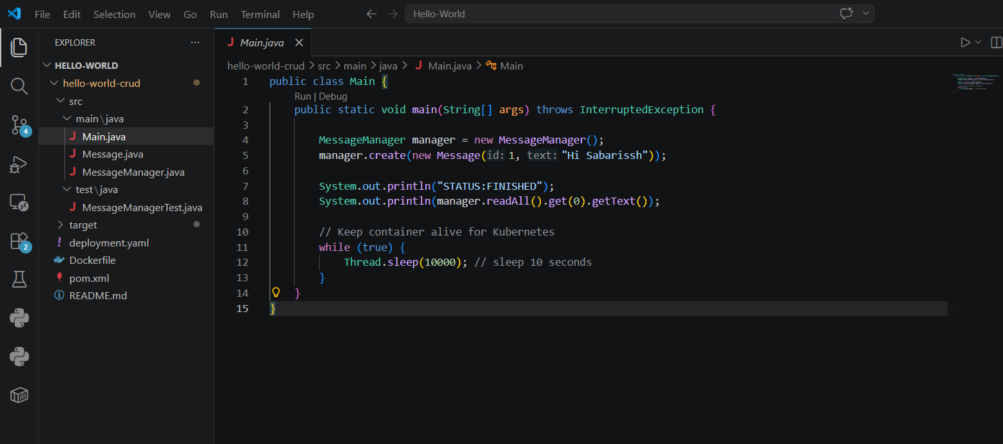

Message.java
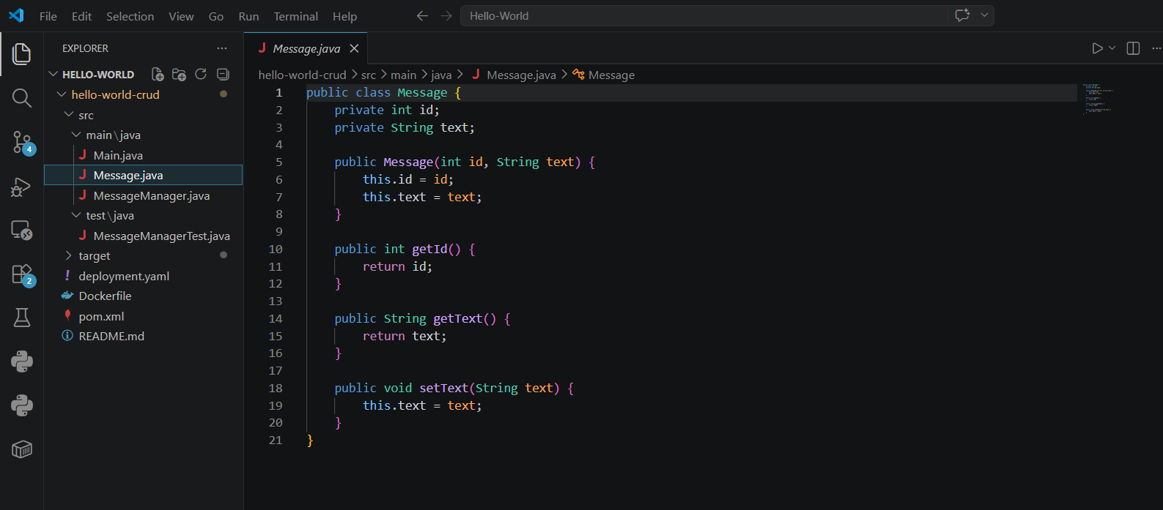
MessageManager.java
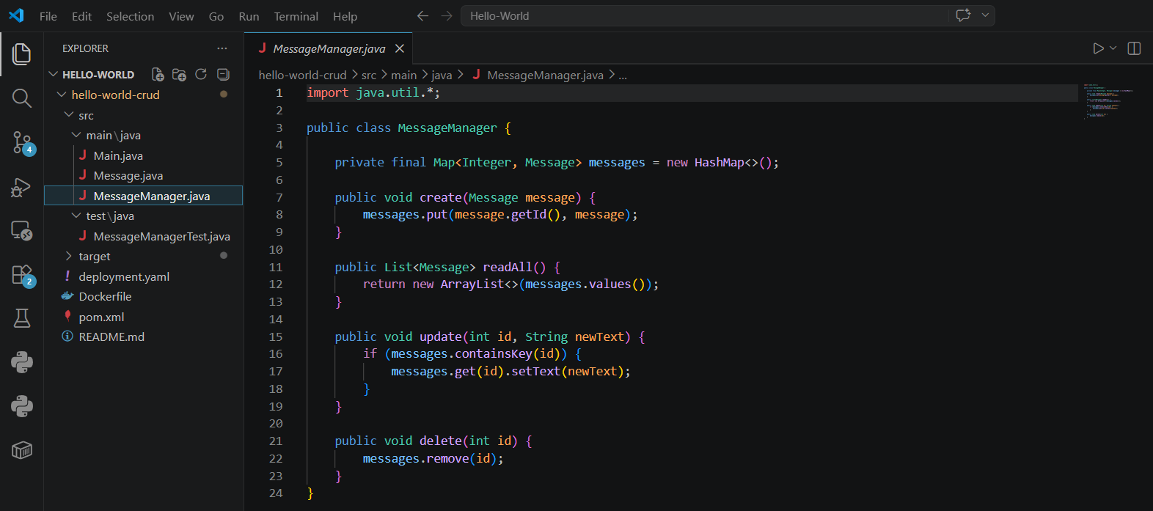

4.2 JUnit Test Cases
MessageManagerTest.java
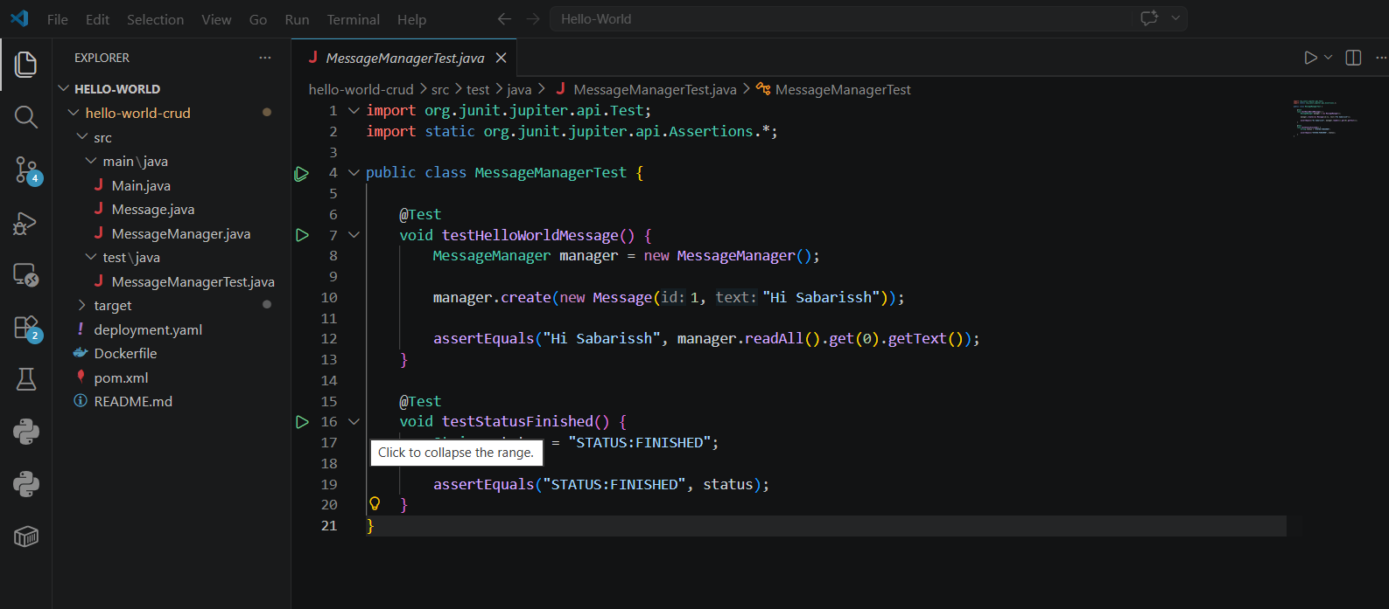

4.3 Dockerfile
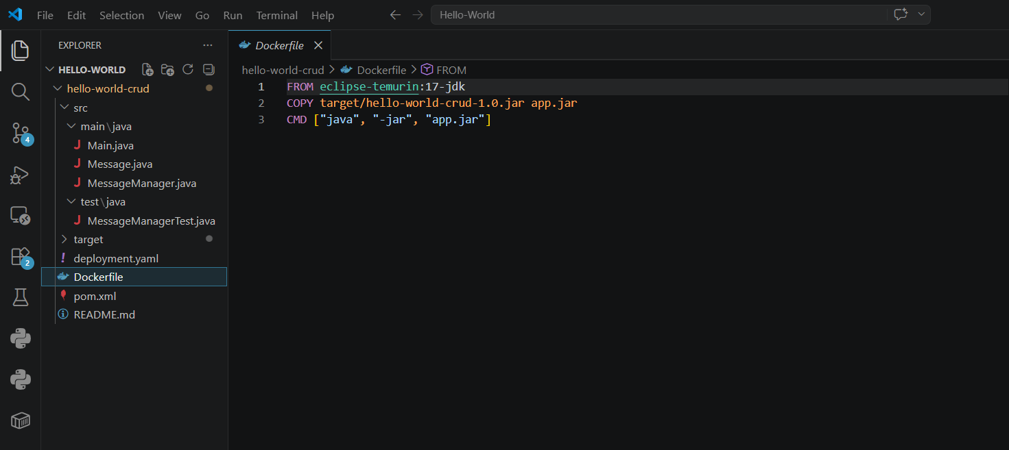

4.4 Kubernetes Deployment
deployment.yaml
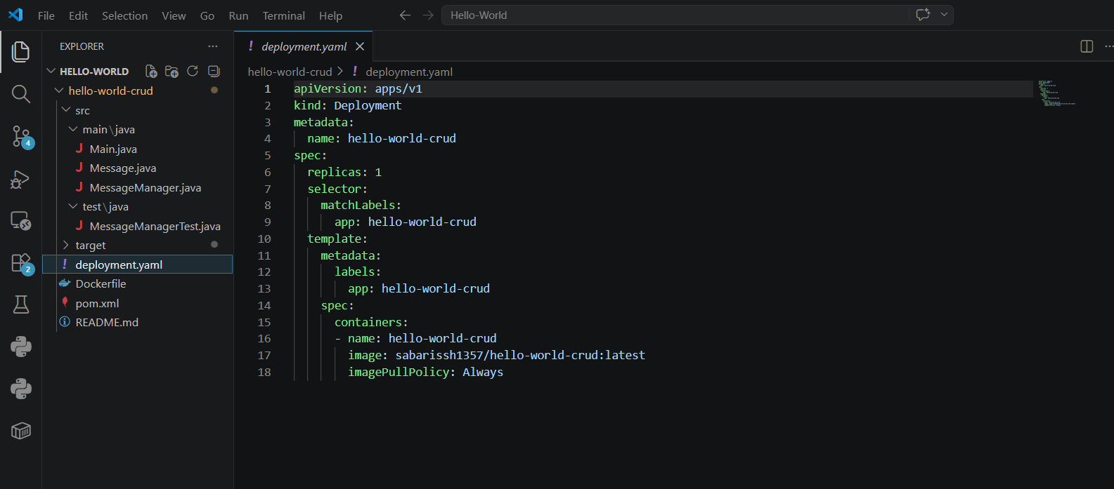

4.5 Maven Configuration
pom.xml
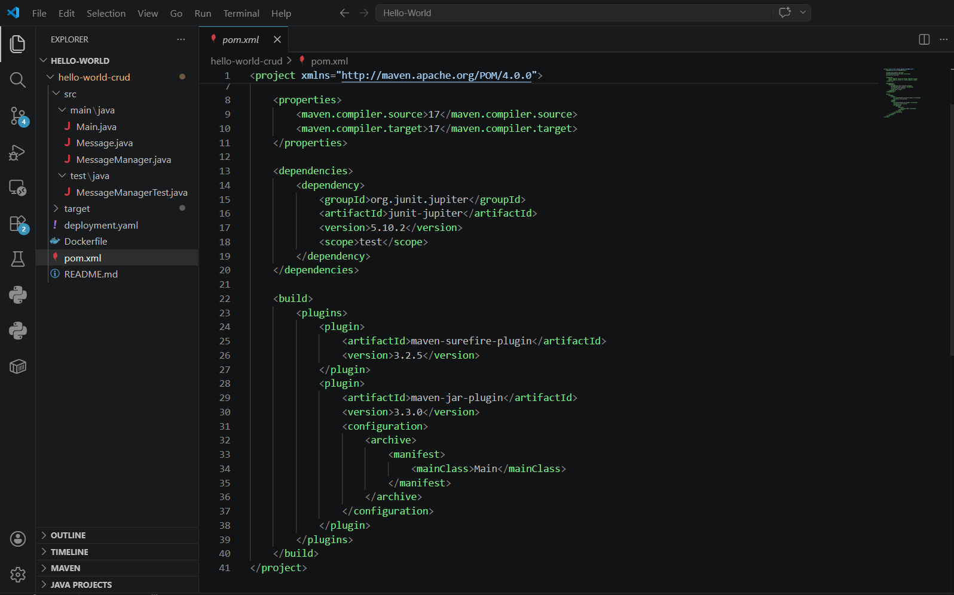

4.6 Commands :
Use appropriate Git Commands to execute the following case studies in VS Code.

Build & Test (MAVEN):
Run Tests: mvn clean test

PICTURE

Build JAR: mvn clean package

PICTURE

Docker Build
Cmd: docker build -t hello-world-crud

PICTURE

Docker Images(docker):

PICTURE

Push to Docker Hub:
Push: docker push Sabarissh1357/hello-world-crud:latest
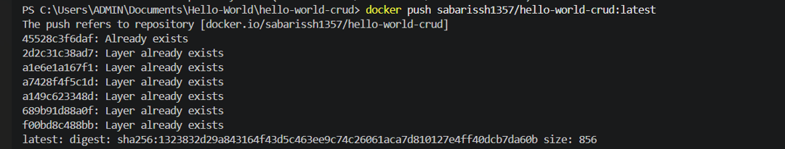

Kubernetes Deployment:
Apply YAML
Cmd: kubectl apply -f deployment.yaml

Check pods
Cmd: kubectl get pods

KUBERNETES(SERVICES):
Run Docker Container(Test):
Cmd: docker run hello-world-crud

PICTURE

5. Git (For Jenkins Integration)

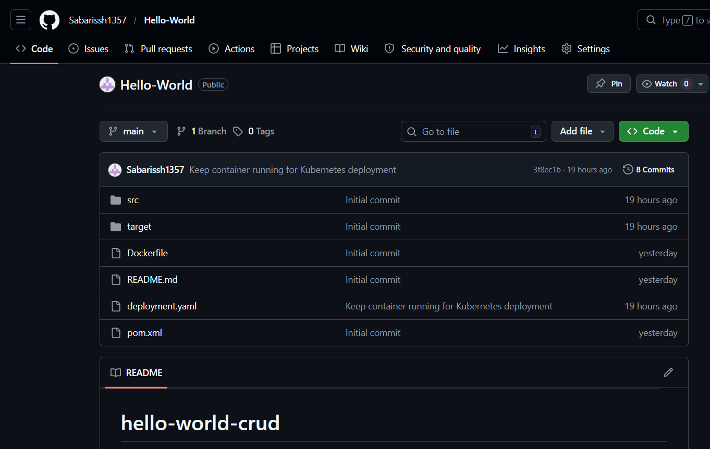

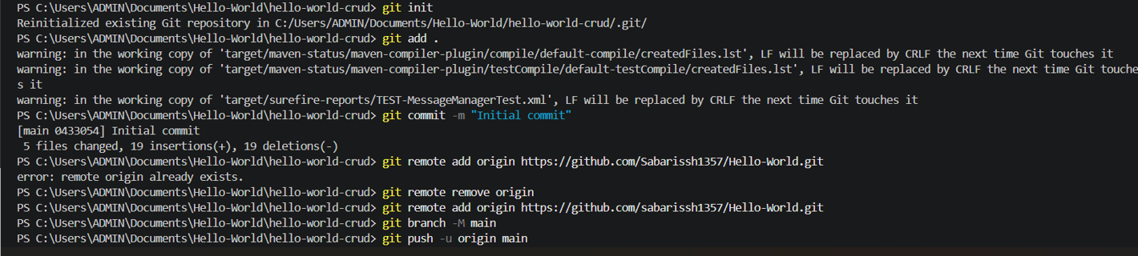
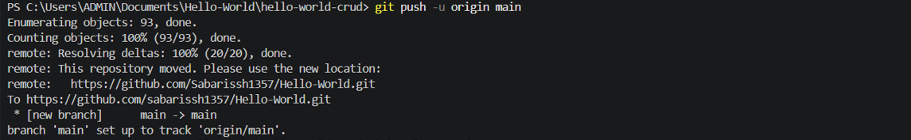

6. Jenkins Pipeline Script
Script:
pipeline {
agent any

environment {
DOCKER_IMAGE = 'sabarissh1357/hello-world-crud:latest'
}

stages {
stage('Clone Repository') {
steps {
git branch: 'main',
url: 'https://github.com/Sabarissh1357/Hello-World.git'
}
}

stage('Build Project') {
steps {
bat 'mvn clean package'
}
}

stage('Run JUnit Tests') {
steps {
bat 'mvn test'
}
}

stage('Build Docker Image') {
steps {
bat 'docker build -t %DOCKER_IMAGE% .'
}
}

stage('Push Docker Image') {
steps {
withCredentials([usernamePassword(
credentialsId: 'dockerhub-creds',
usernameVariable: 'DOCKER_USER',
passwordVariable: 'DOCKER_PASS'
)]) {
retry(3) {
bat 'docker login -u %DOCKER_USER% -p %DOCKER_PASS%'
bat 'docker push %DOCKER_IMAGE%'
}
}
}
}

stage('Verify Program Output') {
steps {
script {
bat 'docker rm -f temp-verify-container || ver >nul'
bat 'docker run -d --name temp-verify-container sabarissh1357/hello-world-crud:latest'

powershell 'Start-Sleep -Seconds 10'

bat 'docker logs temp-verify-container | findstr "Hi Sabarissh"'
}
}
}

stage('Deploy to Kubernetes') {
steps {
bat 'kubectl apply -f deployment.yaml'
}
}
}

post {
success {
echo 'Deployment Successful'
}
failure {
// Ensure cleanup happens even if the findstr check fails
bat 'docker stop temp-verify-container || ver > nul'
bat 'docker rm temp-verify-container || ver > nul'
echo 'Pipeline Failed'
}
}
}

Console output:
SELECT:
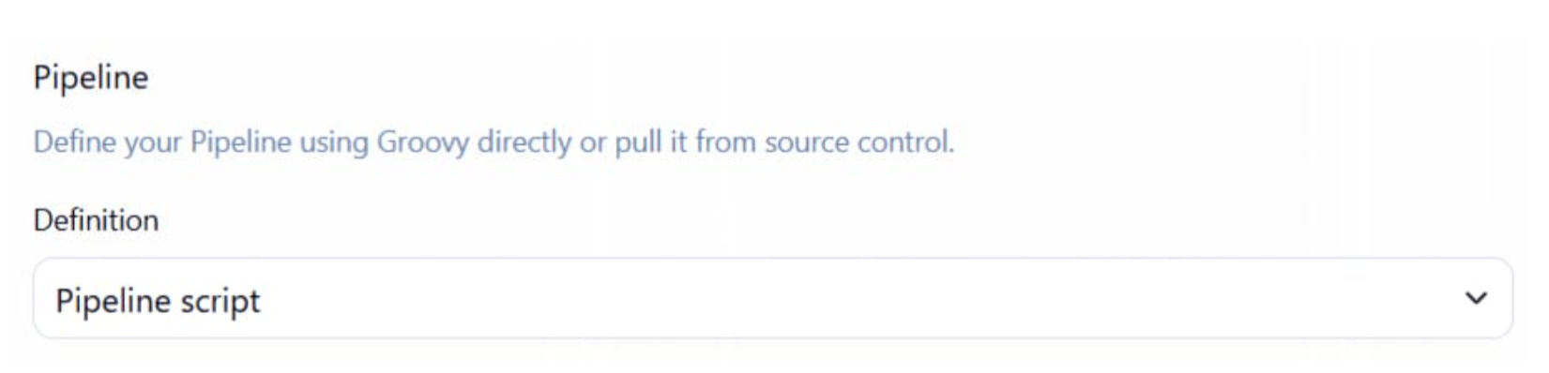
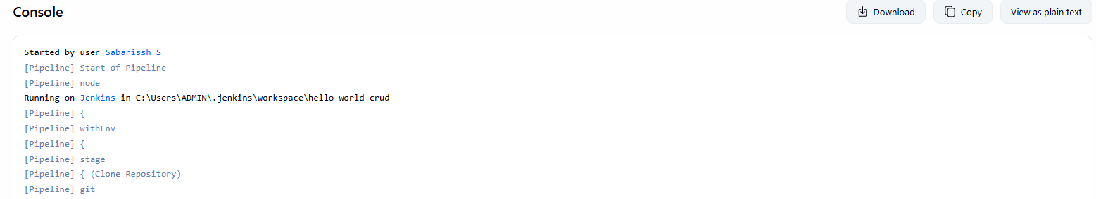

CONTINUES PICTURE WHILE EXAM

FINAL FLOW
1. Maven Build → mvn clean package
2. JUnit Testing → mvn test
3. Docker Image → docker build
4. Docker Push → docker push
5. Kubernetes Deploy → kubectl apply
6. Jenkins Automation → Pipeline

7. CICD Stage View:
TAKE PICTURE THIS AFTER COMPLETING
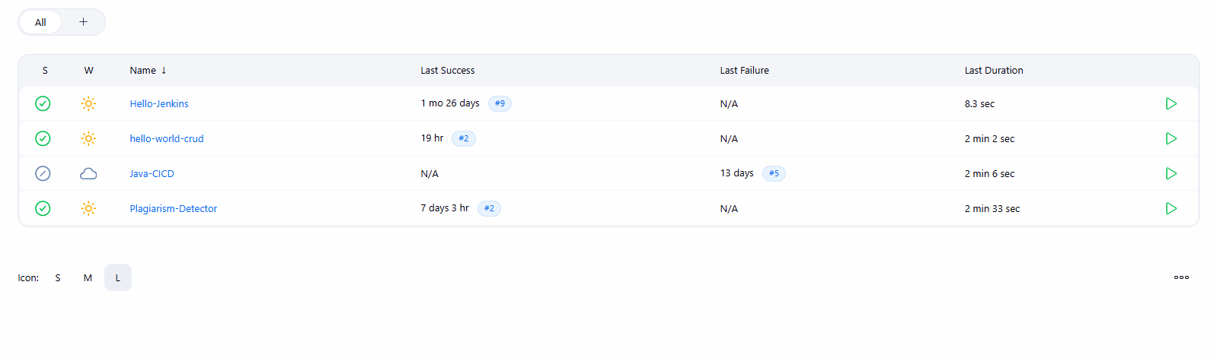

Stage View:
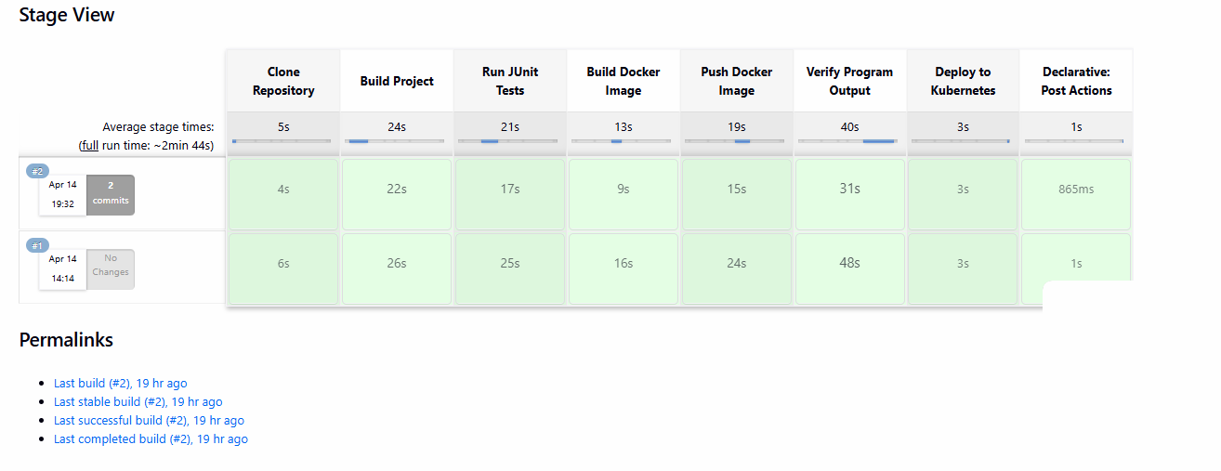

8. Conclusion

